Developer (person who wrote the code) | John Bell
Developer’s assignment group (A, B, or C) | A
Reviewer | Jane Hamsher
Date | April 24, 2017
Instructions
A reviewer will fill out the “Beta” column of this form for the developer. (The reviewer will need a copy of the developer’s lab instructions.) Next, the developer will revise their code based on the review. After revising their code, the developer will fill out the “Release” column of this form to indicate what they have changed.
Criteria | Beta | Release
Part 1 – Walkthrough: Saving Activity State
Is there a document containing screen-shots of the app running? | N | y
From the screen-shots, is it apparent that the exercise was completed successfully? | N/A | y
Comments:

Part 2 – Assignment Group A: Awesome Quotes App
UI |  | Beta
Are there at least 4 TextView widgets, one for the quote, one for the person who said it, two for labels above the EditText widgets? |  | Y
Are there at least 2 buttons, one for showing another quote, one for adding a quote? |  | Y
Is there at least two EditText widget for entering a new quote and the person who said it? |  | Y
Persisting Activity State
In the MainActivity, is OnSaveInstanceState being overridden? |  | Y
Is the quote manager object being serialized and stored in a Bundle object? |  | Y
In OnCreate, is the quote manager object being de-serialized from the Bundle object? |  | Y
If there is nothing stored in the Bundle object, is a new quote manager instantiated? |  | Y
Functionality
Does it build and run without errors? |  | N
Is the first quote in the list shown when the app is started? |  | Y
Is the same quote still shown when the device is rotated? |  | N
Does clicking the “next quote” button show the next quote?
Can the user enter new quotes? (They should be displayed just like the others) |  | Y
Are the quotes entered by the user preserved when the device is rotated, or the app resumed by tapping home and then selecting the app in the “recent apps” list, or restarted by clicking the “back” button and then selecting the app from the “recent apps” list? |  | N
Does everything else work correctly? |  | See below
Comments:
The app looks good, I was able to run it and add quotes and authors. But as you say, when the device rotates things don’t seem to work right.
Complete Programming style for all solutions on the last page.

Programming style for all solutions
Is proper indentation used? |  | Y
Are the UI elements and the variables named descriptively? |  | Y
Have any unnecessary lines of code or files been removed? |  | Y
Are there explanatory comments in the code? |  | N
Do variable names use camel case? (camelCase for example) |  | Y
Are constants named using ALL_CAPS? |  | N/A
Are methods named using PascalCase (aka TitleCase) |  | Y
Is the code DRY (no duplicated blocks of code)? |  | Y

Comments: See above
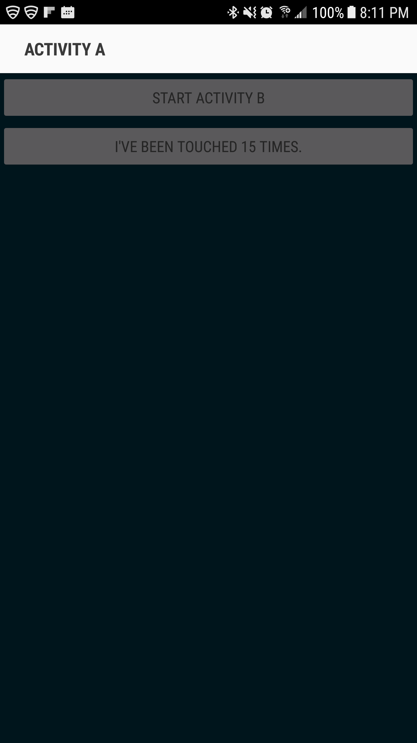
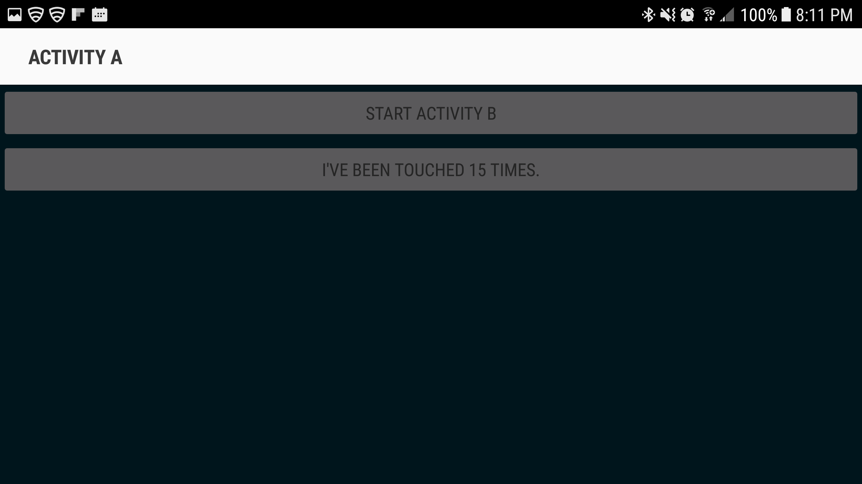
GIT: https://github.com/insidmal/CS235AM.git

